**Business Requirements Document**

**Name:** Ronan Noonan

**Number:** G00384824

**Website:** Amazon.com

**2 Main Features**

1. Managing an account.
2. Searching for a product and adding it to the cart.

**Introduction**

One of the biggest and most well-known online marketplaces in the world is amazon.com. It provides clients from all over the world with access to a wide range of goods and services. Amazon provides something for everyone and has an enormous selection of products. A great website for testing and honing software testing abilities is Amazon, whose website is frequently updated with fresh features. Amazon is a trustworthy and well-known website with a variety of features that make it the perfect website for software testing and practicing software testing abilities.

**Test case 1.00 – Language set to English**

1. Open a browser and search [www.amazon.com](http://www.amazon.com).
2. Click Language and check to see if English selected.

**Amazons home page with English language selected.**

# Managing an account

**Test case 2.00 – Verify that the user can sign up.**

1. Open [www.amazon.com](http://www.amazon.com).
2. Click sign in (top right-hand corner).
3. Click create your amazon account.
4. Enter valid username, password, email/mobile number, and re-enter password.
5. Click Verify email.

*Open* [*www.amazon.com*](http://www.amazon.com)*.*

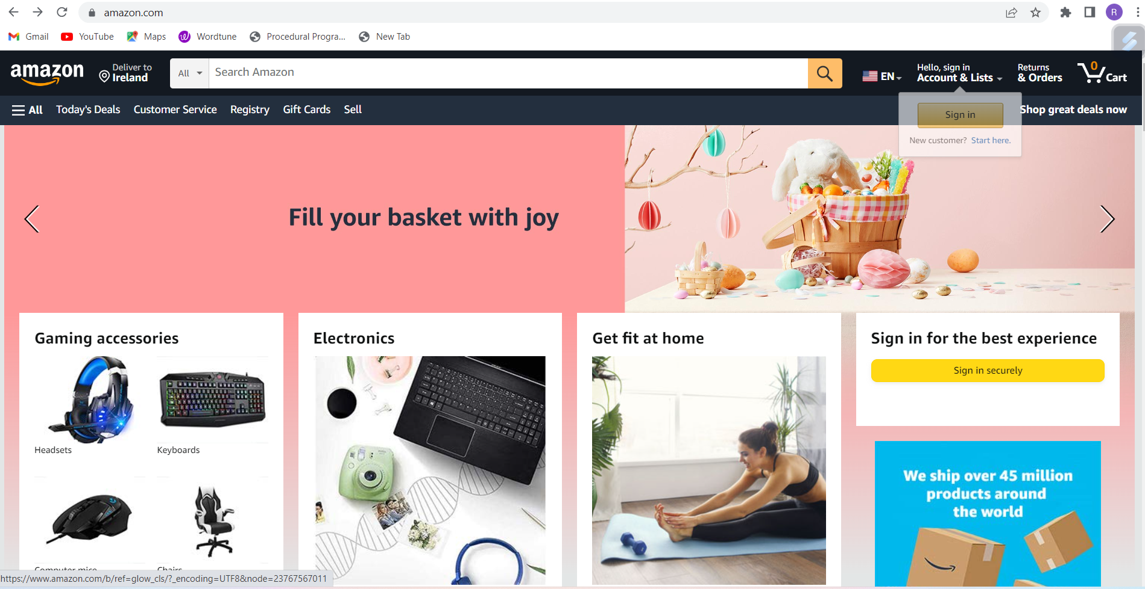

*Sign in (top right-hand corner).*

Create your amazon account.

*Enter valid username, mobile number/email, password, and re-enter password.*

*Verify email.*

**User successfully signed up.**

**Test case 3.00 – Verify that the user can sign In**

1. Open [www.amazon.com](http://www.amazon.com).
2. Click sign in (top right-hand corner).
3. Enter email/mobile number and click continue.
4. Enter password and click sign in.
5. Add a mobile number click skip.

*Click sign in (top right-hand corner).*

Enter email/mobile number.

*Add a mobile number click skip.*

**User has successfully signed in.**

**Test case 4.00 – Verify that the user can sign up with existing email.**

1. Open [www.amazon.com](http://www.amazon.com).
2. Click sign in (top right-hand corner).
3. Click create your amazon account.
4. Enter existing email “G00384824@atu.ie”.

**Can not sign up when the email is already in use.**

**Test case 5.00 – Verify that the user can request password reset.**

1. Open [www.amazon.com](http://www.amazon.com).
2. Click sign in (top right-hand corner).
3. Enter email and click continue.
4. Click forgot password.
5. Re-enter email and click continue.
6. Create new password and re-enter it.

*Enter email and click continue.*

*Click forgot password.*

*Re-enter email and click continue.*

*Enter one-time passcode.*

*Create a new password and re-enter it.*

Su**ccess the user has changed their password.**

**Test case 6.00 – Verify that the user can sign out.**

1. Open [www.amazon.com](http://www.amazon.com).
2. Hover over name (top right-hand corner).
3. Click sign out.

*Click sign out.*

**User has successfully signed out.**

**Test case 7.00 – sign in with no password entered.**

1. Open [www.amazon.com](http://www.amazon.com).
2. Hover over name (top right-hand corner).
3. Click sign in.
4. Enter email.
5. Leave password blank.
6. Click sign in button.

*Click sign in.*

**Error message “Enter your password”.**

**Test case 8.00 – Adding a payment method.**

1. Open [www.amazon.com](http://www.amazon.com).
2. Hover over name (top right-hand corner).
3. Click your account.
4. Click add a credit card or debit card.
5. Enter credit card details.
6. Click Add your card.

*Open “Your account”*

*Click add a payment type.*

*Enter credit card details.*

Card has been successfully added to your account.

**Test case 9.00 – Adding a payment method using illegal credentials.**

1. Open [www.amazon.com](http://www.amazon.com).
2. Hover over name (top right-hand corner).
3. Click your account.
4. Click add a credit card or debit card.
5. Enter credit card details.
6. Click Add your card.

*Click add your card.*

**Error message “Card number is not correct”.**

Searching for a product and adding it to the cart.

**Test case 10.00 – Test that the search bar is displayed on the homepage and is functional.**

1. Open [www.amazon.com](http://www.amazon.com).
2. Click on the search bar.
3. Type in a product.
4. Press enter or click search.

*Click on the search bar.*

*Type in a product*

**

*Click enter.*

**Results show products entered.**

**Test case 11.00 – Test that users can search for a product using a keyword or product name.**

1. Open [www.amazon.com](http://www.amazon.com).
2. Click on the search bar.
3. Type in a keyword.
4. Press enter or click search.

*Keyword*

**

*Click search.*

**Results are tech items.**

**Test case 12.00 – Test that users can filter the search results by price.**

1. Open [www.amazon.com](http://www.amazon.com).
2. Click on the search bar.
3. Type in a product.
4. Press enter or click search.
5. Click on the sort by feature.
6. Select price low to high.

*Sort by feature*

*Low to high*

**Price starts at the lowest and goes up.**

**Test case 13.00 – Test that the product listing displays all necessary information about the product, such as its name, price, rating, and reviews.**

1. Open [www.amazon.com](http://www.amazon.com).
2. Click on the search bar.
3. Type in a product.
4. Press enter or click search.
5. Click on a product.
6. Click on reviews (Towards the bottom of the page).
7. Check if the correct information is being shown.

*Click on a product.*

Click on reviews.

**Reviews show down the bottom of the page.**

**Test case 14.00 – Test that users can add a product to their car from the product listing or the product details page.**

1. Open [www.amazon.com](http://www.amazon.com).
2. Click on the search bar.
3. Type in a product.
4. Press enter or click search.
5. Click on a product.
6. Click add to basket.
7. Click on basket.

*Click add to basket.*

**Error item did not get added when pressed add to basket. Had to be repeated.**

**Test case 15.00 – Test that user’s cart is updated in real-time to reflect the added product.**

1. Open [www.amazon.com](http://www.amazon.com).
2. Click on the search bar.
3. Type in a product.
4. Press enter or click search.
5. Click on a product.
6. Click add to basket.
7. Click on basket.

*Click add to basket.*

*Click on basket.*

**Item has been added to your basket.**

**Test case 16.00 – Test that users can adjust the quantity of the product they want to add to their cart.**

1. Open [www.amazon.com](http://www.amazon.com).
2. Click on the search bar.
3. Type in a product.
4. Press enter or click search.
5. Click on a product.
6. Click add to basket.
7. Click on basket.
8. Click on Quantity and select amount.

*Click on Quantity and select amount.***

**Quantity changed to 3.**

**Test case 17.00 – Test that the user can remove something from their cart.**

1. Open [www.amazon.com](http://www.amazon.com).
2. Click on the search bar.
3. Type in a product.
4. Press enter or click search.
5. Click on a product.
6. Click add to basket.
7. Click on basket.
8. Click on delete under the product.

*Click on delete.*

**

**Item is removed.**

**Test case 18.00 – Test that user can check out.**

1. Open [www.amazon.com](http://www.amazon.com).
2. Click on the search bar.
3. Type in a product.
4. Press enter or click search.
5. Click on a product.
6. Click add to basket.
7. Click on basket.
8. Click on proceed to checkout item.
9. Add payment method.
10. Add delivery address.
11. Click pay in euro.

*Click on proceed to checkout item.*

*Add delivery address and payment method.*

*Click pay in euro.*

*Item successfully purchased.*